1.2 & 1.3 Volumes Worksheet

- Let R be the finite region bounded by the graphs of , , , and . Set up a definite integral which represents the volumes of the following solids. Use your calculator to evaluate each integral.
- The volume of the solid with base R for which the cross-sections perpendicular to the y-axis are semi-circles.
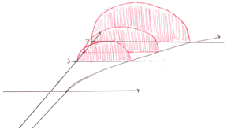
Since the cross sections stack up from top to bottom we need to integrate with respect to y.
Solve equations for x:

Find a formula for the area of the cross-section:
The radius of the circle is:
The area of the cross-section is: Setup:
Evaluate:

- The volume of the solid formed when R is revolved around the y-axis. Determine this volume in the following two ways.
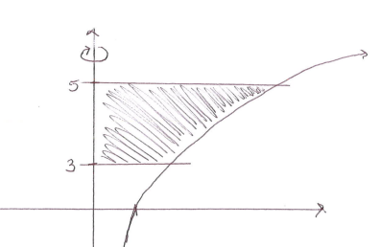
- Integrate with respect to x.
We can use shells which extend horizontally, so we need to integrate with respect to x.
Setup:
Evaluate:

- Integrate with respect to y.
The cross-sections are circles which stack vertically, so we need to integrate with respect to y.
Setup:
Evaluate:

- Let R be the finite region bounded by the graphs of , , & . Set up a definite integral which represents the volumes of the following solids.
- The volume of the solid with base R for which the cross-sections perpendicular to the x-axis are squares.

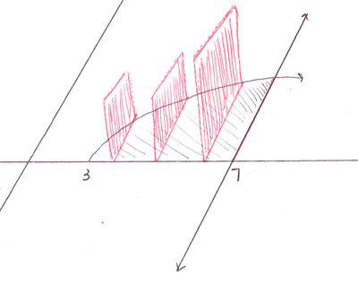
Since the cross sections stack up from left to right we need to integrate with respect to x.
Find a formula for the area of the cross-section:
The side of the square has length:
The area of the cross-section is:

Setup:
Evaluate:

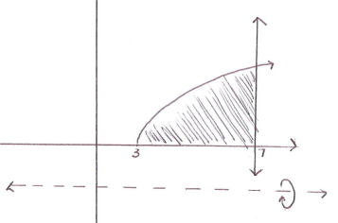
- The volume of the solid formed when R is revolved around the line . Determine this volume in the following two ways.
    - Integrate with respect to x.
We can use washers which stack horizontally, so we need to integrate with respect to x.
Setup:
Evaluate:

    - Integrate with respect to y.
We can use shells which extend vertically, so we need to integrate with respect to y.
Solve equations for x:

Setup:

Evaluate:

3 – 4: Let R be the region bounded by the given curves in the first quadrant. Complete each of the following:
- Sketch a picture of the region R and the solid generated when R is revolved about the given line.
- Find the volume of the solid using the disk/washer method.
- Find the volume of the solid using the shell method.
- Verify that the results from (b) and (c) are the same.

- , revolved around the x-axis.
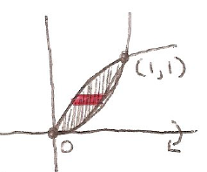
- Sketch a picture of the region.

- Washers:
Since the washers stack up left to right, this problem should be done in terms of x.

Setup:
Evaluate:
- Shells:
Since the shells stack up top to bottom, this problem should be done in terms of y.

Setup:

Evaluate:

- Indeed we see that both parts (a) and (b) have the same answer of .

- , , & revolved around the line .
- Sketch a picture of the region.
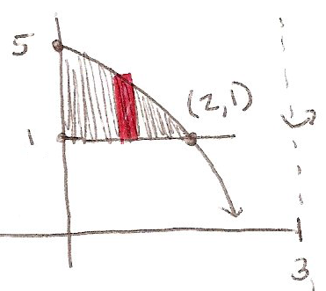

- Washers:
Since the washers stack up vertically, this problem should be done in terms of y.
Setup:

Evaluate:

- Shells:
Since the shells stack up left to right, this problem should be done in terms of x.
Setup:
Evaluate:

- Indeed we see that both parts (a) and (b) have the same answer of .

- Consider the region bounded by the curves , , & . If this region is revolved around the line then answer the following questions.
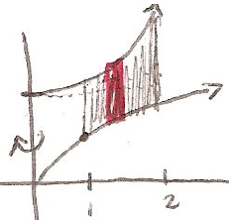
- Sketch a picture of the region.

- What is the best method to compute the volume of the solid? Attempt to fill out the method in the table that you see as easier (if you are unsure observe both methods and then decide). Compute the volume.
Disks/Washers | Shells
Inner Radius (R): | Radius: x
Outer Radius (r): | Height:
This is very complicated… We need 3 integrals!

Disks/Washers:

Shells:
Indeed we see that both parts (a) and (b) have the same answer of .

- Consider the region bounded by the curves , , & . If this region is revolved around the line then answer the following questions.
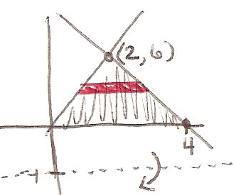
- Sketch a picture of the region.

- What is the best method to compute the volume of the solid? Attempt to fill out the method in the table that you see as easier (if you are unsure observe both methods and then decide). Compute the volume.
Disks/Washers | Shells
Inner Radius (R): | Radius:
Outer Radius (r): | Height:
This is still fairly complicated… We need 2 integrals!
Or we could double one of the following integrals.
Disks/Washers:

Shells:

Indeed we see that both parts (a) and (b) have the same answer of .

